Book
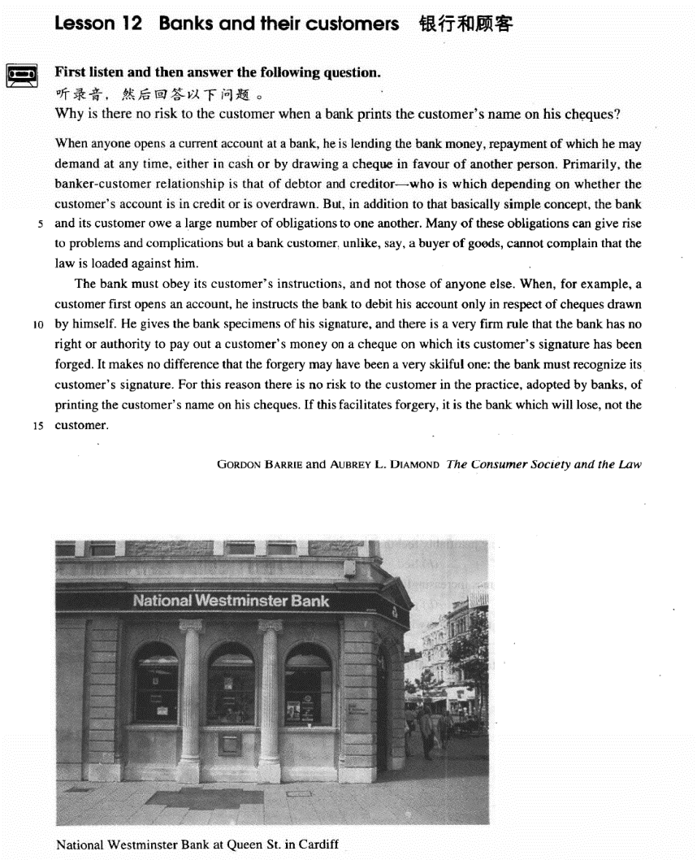

课文
When anyone opens a current account at a bank, he is lending the bank money, repayment of which he may demand at any time either in cash or by drawing a cheque in favour of another person.
任何人在银行开一个活期账户，就等于把钱借给了银行。这笔钱他可以随时提取，提取的方式可以是取现金，也可以是开一张以他人为收款人的支票。

Primarily, the banker-customer relationship is that of debtor and creditor -- who is which depending on whether the customer's account is in credit or is overdrawn.
银行与储户的关系主要是债务人和债权人的关系。究竟谁是债务人谁是债权人，要看储户是有结余还是透支。

But, in addition to that basically simple concept, the bank and its customer owe a large number of obligations to one another.
除了这一基本的简单的概念外，银行和储户彼此还需承担大量义务。

Many of these obligations can give rise to problems and complications but a bank customer, unlike, say, a buyer of goods, cannot complain that the law is loaded against him.
其中许多义务往往引起问题和纠纷。但是储户不能像货物的买主那样来抱怨法律对自己不利。

The bank must obey its customer's instructions, and not those of anyone else.
银行必须遵照储户的嘱托办事，不能听从其他人的指令。

When, for example, a customer first opens an account, he instructs the bank to debit his account only in respect of cheques drawn by himself.
比如，储户首次在银行开户时，嘱咐银行他的存款只能凭本世人签字的支票来提取。

He gives the bank specimens of his signature, and there is a very firm rule that the bank has no right or authority to pay out a customer's money on a cheque on which its customer's signature has been forged.
他把自己签名的样本交给银行，对此有一条非常严格的规定：银行没有任何权利或理由把储户的钱让伪造储户的支票取走。

It makes no difference that the forgery may have been a very skillful one: the bank must recognize its customer's signature.
即使伪造得很巧妙，也不能付款，因为银行有责任辨认出其储户的签名。

For this reason there is no risk to the customer in the practice, adopted by banks, of printing the customer's name on his cheques.
因此，某些银行已采用把储户印在支票上的作法。这种做法对储户毫无风险。

If this facilitates forgery, it is the bank which will lose, not the customer.
如果因这种作法出现了伪造的话，受损失的将不是储户，而是银行。

词汇讲解

- template [pʌŋktʃʊ'ælətɪ]
- template show.

current
- current ['kʌrənt] adj. 当前的，现在的，流行的
- current problems
- current events / affairs
- the current president

“银行相关”：
current account 活期账户
checking account 活期账户
savings account 定期账户
deposit account 定期账户
open an account 开户
close an account 销户
deposit / bank v.存款
- You’d better deposit / bank your money.

draw / withdraw … from … 取款
take … out of … 取款
- He drew / withdrew $100 from his bank (account).
- He took $100 out of his bank (account).

overdraw v.透支
- My account is overdrawn by $200.

cash / encash v.兑换现金
- to cash / encash a check 把支票兑换成现金

debtor
- debtor ['detə(r)] adj. 债务人，借方

“银行相关”：
debtor n. 英文解释：person who owes money to sb. 债务人，借方
creditor n. 英文解释：person to whom money is owed 债权人，贷方

debit v. 把……计入借方，记上客户支出的钱
- Debit $100 against Mr. Smith’s account. 从账户中取走…
- Debit Mr. Smith’s account with $100. 从账户中取走…

debit n. 账户的借方；账户中提取的款项

credit v. 把……计入贷方，记上客户存入的钱
- Credit Mr. smith’s account with $100. 存入…

credit n. 账户的贷方；账户中存入的款项
- Your account is in credit. 账户中有余额

obligation
- obligation [7ɒblɪ'geɪʃn] adj. 责任，义务
obligation to n. / to do sth 对于…的义务/有义务去做…

- America’s obligation to its allies
- Employers have an obligation / are under an obligation to treat all employees equally.

meet / honor / fulfill one’s obligation 履行义务
sense of obligation 责任感
legal obligation 法律义务
moral obligation 道德义务
mutual / reciprocal obligation 相互义务

【近义词】【辨析】
duty （强调主动承担，强调基于道义、良心上的）
obligation （强调不得不履行的责任、义务）
responsibility （强调为某事负责）

complication
- complication [7kɒmplɪ'keɪʃn]n. 复杂的情况，纠纷
complication n. 纠纷
- complications between two parties / countries …之间的纠纷
- legal complications 法律纠纷
- avoid complications 避免纠纷
- cause complications 导致纠纷
- produce further complications 产生进一步的纠纷

complication n.并发症
- If diabetes is not treated properly, complications will set in.

【同根词】
complicate vt. 使复杂化；使恶化；使卷入
complicated adj. 难懂的，复杂的

【词根】
“plic” = fold 折叠
implicate vt. 使卷入；涉及；暗指；影响
- He was implicated in the crime.

explicate v. <正>解释，说明
- The teacher is explicating an abstruse poem.

duplicate 复制
- He duplicated his former mistakes.

supplicate 恳求
- I supplicated her forgiveness.

specimen
- specimen ['spesɪmən] n. 样品，标本
specimen / sample n. 样品，标本
- a specimen / sample signature
- a blood specimen / sample
- a urine specimen / sample

sample n. 试用品
- samples of a new shampoo

adopt
- adopt [ə'dɒpt] v. 领养；采取，采用；正式批准
表达“领养”：
- adopt an orphan
- adopted son
- adoptive parents 养父母
- foster-parents 养父母

表达“采取、采用”：
- adopt a new idea
- adopt a new technique

表达“正式批准”：
- The Senate unanimously adopted the committee’s proposals.

【同根词】
adoption n. 领养；采纳，采用
- This textbook has adoptions in many countries.

【形近词】
adept adj. 熟练的，内行的
be adept at / in … 在…很熟练

adapt v.（使）适应；改编
- She quickly adapted to the new climate.
- The movie was adapted from a novel.

facilitate
- facilitate [fə'sɪlɪteɪt] v. 使某事更容易
- Modern devices facilitate domestic work.

【同根词】
facility n.（常用复数）（使事情便利的）设备，设施
- drainage facilities
- medical facilities
- recreational facilities
- public health facilities
- lodge and eating facilities

facile adj. easily obtained or achieved (and so not highly valued) 容易得
到的（因而没有太大价值的）
- a facile success

【词根】
“fac” = make 做
manufacture 制造
benefactor n. 恩人；捐助者；施主
malefactor n. 作恶者；罪犯；坏人

【词根】
“-ile” 易于的
fertile adj. 富饶的，肥沃的；能生育的

fragile adj. 脆的；易碎的
facile (“fac” + “ile”)

课文讲解

（第一段）

When anyone opens a current account at a bank, he is lending the bank money, repayment of which he may demand at any time either in cash or by drawing a cheque in favour of another person.

语法分析：
When anyone opens a current account at a bank（when...时间状语从句）, he is lending the bank money, repayment of which he may demand at any time, either in cash or by drawing a cheque in favour of another person（方式状语）. （repayment of which… 定语从句，which修饰money，repayment of which做demand的宾语）

知识点（1）
lend sth. to sb. 把…借给某人 （借出去）
= lend sb. sth.

loan sth. to sb. 把…借给某人 （借出去）
= loan sb. sth.

borrow sth. from sb. 向某人借…（借进来）
borrow sb. sth. X错误搭配

表达“你能不能借给我 100 块钱？”：
- Would you borrow me ￥100? X错误搭配
- Would you lend me ￥100?
- Would you lend ￥100 to me?
- May I borrow ￥100 from you?
- May I borrow you ￥100? X错误搭配

知识点（2）
【课文句型提炼】
when anyone …, he is … 无论是谁（做某事），就等于在……
- 造句：无论是谁试图徒步穿越这个山口，就等于在生命冒险。

- When anyone tries to cross the pass on foot, he is risking his life.

知识点（3）Lesson03-32
语法：“名词 + 介词 + 关系代词” 引导非限定性定语从句；前提是定语从句修饰的不是先行词本身，而是先行词相关的东西或一部分

- 造句：他有两个儿子，其中的一个死于战火。
- He has two sons, one of whom died in the war.

- 造句：演讲者提了 (pose) 四个问题，它们的答案被证明非常具有启发性(illuminating)。
- The speaker posed four questions, the answers to which proved very illuminating.

- She hurried home to feed her cats, one of which had just had kittens.

- This echo-location in bats is often compared with radar, the principle of which is similar.
- The most valuable find of all was the ship's log book, parts of which it was still possible to read.

知识点（4）
repayment of … 偿还、归还
- the repayment of debt 债务偿还

repay sb. sth. 归还某人某事
= repay sth. to sb. 把某事归还某人

pay sb. back 归还某人某事
pay back sth. 归还某事
- I’ll pay you back tomorrow.

pay off one’s debts 还清债务
clear one’s debts 清偿债务
give sb. a refund 给某人退款
- We’ll give you a refund if you’re not entirely satisfied.

reimburse sb. 报销
- Pay for the hotel room when you leave, and the company will reimburse you later.

知识点（5）
in favor of …（支票）以某人/某部门为受款人
- Checks should be written / drawn in favor of School.

Primarily, the banker-customer relationship is that of debtor and creditor -- who is which depending on whether the customer's account is in credit or is overdrawn.

语法分析：
Primarily, the banker-customer relationship is that（代替relationship） of debtor and creditor—who is which（主语从句） depending on whether the customer's account is in credit or is overdrawn. （独立主格）

知识点（1）
表达“主要的”：副词同义替换
Primarily
Principally
Chiefly
Mainly
Largely
Above all
First and foremost

知识点（2）
the banker-customer relationship is that of debtor and creditor
相当于：the relationship between / of banks and customers

知识点（3）Lesson03-57
debtor and creditor
语法：语义相对的名词并列，常省略冠词
- Father and son went to New York by a morning train.
- We are brother and sister.
- Husband and wife are talking about the boy’s future.
- Please pass me pencil and paper.
- heart and soul
- knife and fork
- the relation between teacher and student
- the conflict between mother and son

知识点（4）Lesson03-29
whether和if 从句区别：
表示“是否”时不能用 if 的几种情况：
1）.主语从句位于句首时，不能用 if
- If she likes the present is not clear to me. X错误
- It is not clear to me if / whether she likes the present. √ （改正，放在句中）
- Whether she likes the present is not clear to me. √ （改正，句首改成whether）

2）.引导表语从句时，不能用 if
- The question is if we have enough money. X错误
- The question is whether we have enough money. √改正

3）.引导同位语从句时，不能用 if
- You have yet to answer my question if I can count on your help. X错误
- You have yet to answer my question whether I can count on your help. √改正

4）.作介词宾语时，不能用 if
- He was worrying about if he had hurt her feelings. X错误
- He was worrying about whether he had hurt her feelings. √改正

5）.引导动词不定式时，不能用 if
- I don’t know if to see my doctor today. X错误
- I don’t know whether to see my doctor today. √改正

6）.直接跟 or not 时，不能用 if
- Please tell me if or not you agree. X错误
- Please tell me whether or not you agree. √改正
- Please tell me if you agree or not. √改正

知识点（5）
be overdrawn 有赤字
= be in the red
- Your account is overdrawn / in the red.

But, in addition to that basically simple concept, the bank and its customer owe a large number of obligations to one another.

知识点（1）
表达“除了…之外，还…”：
in addition to …
besides …
as well as …
together with …
along with …
apart from …
aside from …

知识点（2）
owe sth. to sb. 前某人某事
= owe sb. sth.

owe obligations to sb. 对某人有义务
= have obligations to sb.
- Parents owe / have obligations to their children. I owe you (a lot).
- You owe him an apology.
- You owe him an explanation.

知识点（3）
one another
each other
当代英语中可替换，没有限制

Many of these obligations can give rise to problems and complications but a bank customer, unlike, say, a buyer of goods, cannot complain that the law is loaded against him.

语法分析：
Many of these obligations can give rise to problems and complications but a bank customer, unlike, say, a buyer of goods（插入语）, cannot complain that the law is loaded against him.

知识点（1）Lesson03-04
give rise to sth. (fml.) 导致……（正式表达）
- The president’s absence has given rise to speculation about his health.
- This can give rise to curious situations, as it did in the case of Alfred Bloggs who worked as a dustman for the Ellesmere Corporation.

【近义词组】表达“导致”：
cause …
effect …
result in …
bring about …
lead to …
contribute to …
account for …
set up …
- The slump on Wall Street set up a chain reaction in stock markets around the world.

produce / create / generate
- His announcement produced / created / generated gasps of amazement.

trigger / spark / precipitate
- One small error triggered / sparked / precipitated the calamity.

知识点（2）
sth. is loaded against … 英文解释：used to say that a system, situation, or organization is unfair and some people have a disadvantage 对……不公平
- The justice system is loaded against ethnic minorities.

【近义词组】表达“对……有偏见”： Lesson03-53
be prejudiced against …
be biased against …
- The early Christian church was prejudiced / biased against Jews.
- He seemed a bit biased against women in my opinion. （偏见）
- The fact that the policeman was prejudiced against foreigners could not be recorded in the official files.

【辨析】
be biased in favor of / toward(s) … 对…偏袒的
be partial to / toward(s) … 对…偏袒的
- The judge is biased in favor of the plaintiff. （偏袒）
- The referee was clearly partial to the other side. （偏袒）

（第二段）

The bank must obey its customer's instructions, and not those of anyone else.

知识点（1）
obey instructions 遵守命令
take instructions 接受命令
follow instructions 按照命令
await instructions 等候命令

When, for example, a customer first opens an account, he instructs the bank to debit his account only in respect of cheques drawn by himself.

语法分析：
When, for example（插入语）, a customer first opens an account（when...时间状语从句）, he instructs the bank to debit his account only in respect of（=about） cheques drawn by himself（后置定语）.

知识点（1）
【近义词组】表达“关于”：介词短语
in respect of
with respect to
with regard to
concerning
regarding
respecting
- US foreign policy ~~~ Cuba

He gives the bank specimens of his signature, and there is a very firm rule that the bank has no right or authority to pay out a customer's money on a cheque on which its customer's signature has been forged.

语法分析：
He gives the bank specimens of his signature, and there is a very firm rule that the bank has no right or authority to pay out a customer's money on a cheque on which its customer's signature has been forged（which...定语从句）. （that... 同位语从句）

知识点（1）
signature n. 署名；签名；信号
autograph n. （名人的）亲笔签名
- I’ve got lots of famous actors' autographs.

sign v. 签署
- Where do you want me to sign my name?

sign for … 签收
- Could you sign for this package, please?

initial vt. 用姓名的首字母签名
- The memo has been initialled / initialed by the president.

知识点（2）
authority n. [U] 英文解释：right to act in a specific way 职权，权限
- Only the treasurer has authority to sign checks.

知识点（3）
pay out 英文解释：to pay a lot of money for something 支付（大笔的钱）
- We’re paying out $300 a month on our mortgage.

It makes no difference that the forgery may have been a very skillful one: the bank must recognize its customer's signature.

知识点（1）
make a difference 有用
make some difference 有点用
make no difference 没用

For this reason there is no risk to the customer in the practice, adopted by banks, of printing the customer's name on his cheques.

语法分析：
For this reason（介词短语做状语） there is no risk to the customer in the practice, adopted by banks（插入语）, of printing the customer's name on his cheques（介词of引出同位语）.

知识点（1）
【近义词组】表达“因此”：
for this reason
thus
therefore
ergo
as a result
as a consequence
so
hence
thereupon
accordingly
consequently
in consequence

知识点（2）
risk of 做某事的风险
- the risk of serious injury

risk to 对某事的风险
- There is no risk to customers.

知识点（3）
practice n.习惯性的做法，惯例
the practice of doing sth. 做某事的惯例
- the practice of closing shops on Sundays
- the practice of dumping waste into the sea

If this facilitates forgery, it is the bank which will lose, not the customer.

语法分析：
If this facilitates forgery（if... 条件状语从句）, it is（强调句） the bank which（强调句） will lose, not the customer.

知识点（1）
facilitate … v. 使某事更容易

【近义词组】
ease / smooth the way for …使某事更容易

- The agreement will ease / smooth the way for other countries to join the EU.

知识点（2）
一般强调句：
it is/was +被强调部分 + that/who(m)+ 从句 可以强调句子中任何非谓语的部分；只用于书面语

特殊强调句：
it is … which …（尤其用于科技、说明文体）
- It is heat which makes matter expand and melt.
- It is the release of nuclear energy within the Sun which enables it to send out so much energy to the earth.

知识点（3）【课文句型提炼】Lesson04-05
if …, it is … that / which / who(m) …, not …
如果…，那么是…，而不是…

- If this facilitates forgery, it is the bank which will lose, not the customer. If there is one—which I take leave to doubt—then it is older people who create it, not the young themselves.

